MECE-606 Systems Modeling Project

February 4-18, 2016, Rochester, NY, USA

**Two Mass-Spring-Damper simulation**

**Zeyar Win**

Department of Mechanical Engineering

Rochester Institute of Technology

Rochester, NY 14623

Email. Zxw6805@rit.edu

**ABSTRACT**

There are many ways to model and simulate systems. In this project, Matlab, Simulink, Matlab ode45 function call and Simscape tools are used to simulate the two mass-spring-damper system’s dynamic model. The characteristic of the mass-spring-damper dynamic model such as stability, period, damping, oscillation, and etc. can be observed in the displacement vs time and velocity vs time graphs with force being used and unused.

**INTRODUCTION**

The two mass spring damper system is as below.

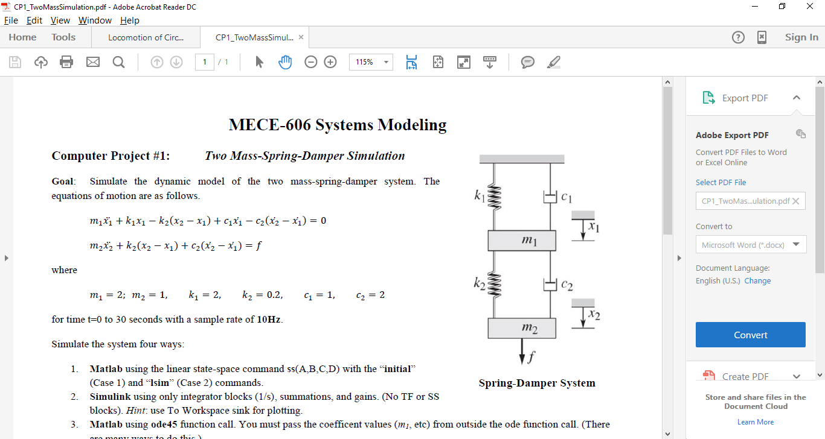

Figure 1: Mass-spring-damper system

There are two cases. First case is that no force is being applied to the system but the mass m1 is one meter from its original equilibrium point. Second case is when the force is exerted on mass m2 to elongate the spring with all masses resting at its initial equilibrium positions. For both cases, the displacement will oscillate for some time and become stable eventually. The velocity will be different in for those cases since various forces and accelerations

affect masses and springs. Matlab tools are used to simulate the system’s behavior.

**ANALYSIS**

The equation of motion can be described as:

$$m_{1}x_{1}^{''}+k_{1}x_{1}-k_{2}\left(x_{2}-x_{1}\right)+c_{1}x^{'}-c_{2 }\left(x_{2}'-x_{1}'\right)=__(1)$$

${ m}_{2}x_{2}^{''}+k_{2}\left(x_{2}-x_{1}\right)+c_{2}\left(x_{2}^{'}-x_{1}^{'}\right)=f_____(2)$

in which

$$m_{1}=2, m_{2}=1 , k_{1}=2, k_{2}=0.2 , c_{1}=1, c_{2}=2$$

The equations (1) and (2) can be simplified into

$x_{1}^{''}=-\frac{k_{1}}{m_{1}}x_{1}+\frac{k_{2}}{m_{1}}\left(x_{2}-x_{1}\right)-\frac{c_{1}}{m_{1}}{ x}^{'}+\frac{c_{2 }}{m_{1}}\left(x_{2}'-x_{1}'\right)$___(3)

${ x}_{2}^{''}=-\frac{k_{2}}{m_{2}}\left(x_{2}-x_{1}\right)-\frac{c_{2}}{m_{2}}\left(x_{2}^{'}-x_{1}^{'}\right)+\frac{f}{m_{2}}_____(4)$

Thus, the state space representation in terms of first order linear differential equations is as follows.

$$Z^{' }= \left[\begin{matrix}0 & 1 & 0 & 0 \\ -\frac{k_{1}+k_{2}}{m_{1}} & -\frac{c_{1}+c_{2}}{m_{1}} & \frac{k_{2}}{m1} & \frac{c_{2}}{m_{1}} \\ 0 & 0 & 0 & 1 \\ \frac{k_{2}}{m_{2}} & \frac{c_{2}}{m_{2}} & -\frac{k_{2}}{m_{2}} & -c_{2}/m_{2}\end{matrix}\right]\left[\begin{matrix}x_{1} \\ x_{1}^{'} \\ x_{2} \\ x_{2}^{'}\end{matrix}\right]+\left[\begin{matrix}0 \\ 0 \\ 0 \\ \frac{1}{m_{2}}\end{matrix}\right]f(t)$$

C matrix [1 0 0 0] can be used to show the output in terms of mass 1 displacement.

${ Z}^{' }$ is used in Matlab, Matlab ODE function call and Simulink to simulate the system.

**SIMULATION**

Simulink as in figure 2 uses differential equations 3 and 4. 1/s block is acted as integrator. By integrating the acceleration, the velocity is obtained. After integrating velocity, the displacement is obtained. The adding and subtracting blocks are used according to equations 3 and 4.

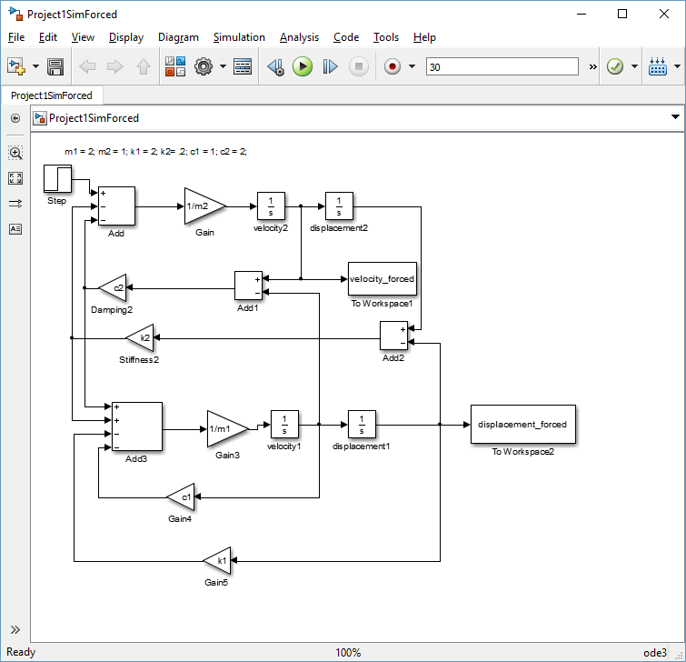Figure 2: Simulink of mass spring damper system

The simulation of mass spring damper system can be observed as in figure 3.

 Figure 3: Simulation of spring mass damper system

As the same mass spring damper system is simulated via four different methods, the identical plot is obtained for force and no force cases. Matlab is useful to compare all data in one graph as in figure3.

The linear system is changed to non-linear system by replacing mass m1 with the m1^3 and k1 with 5N/m. The simulation of the changed system can be seen as in figure 4.



Figure 4: The simulation result of non-linear system

The linear and non-linear models of ODE45 function call are compared as in figure 4.



Figure 4: Comparison of ODE function to linear and non-linear systems

Among the four methods of simulating the system, Simscape simulation is not reliable since it doesn’t have in-depth computation and analysis for complex projects. With Matlab state space representation or Simulink blocks, the equation of motion can be observed and if something is wrong, it can be corrected. Simscape has difficulties in simulating non-linear models which occur in real life.

**CONCLUSION**

The simulation of two mass-spring-damper linear model system is successful using four ways and non-linear model system two different methods. These methods create the same identical graphs. Determining the coefficients of model in m file loaded into workspace and used by Simulink or ode45 is very useful for systems modeling since in real life some parameters of the system are unknown. The loop code in Matlab can help find the values fit the model which is of interest. One thing to note about ODE45 and Simulink is that ODE45 is a variable step solver. Overall, Matlab is a powerful software to analyze, design and model the systems.